Stage 3 – Exhaust Port
COURSE DESIGNER: Rocky Perillo
SCORING: Comstock 19 rounds.
TARGETS: 8 cardboard targets, 1 steel target
SCORED HITS: 2 Best hits per carboard will be scored.

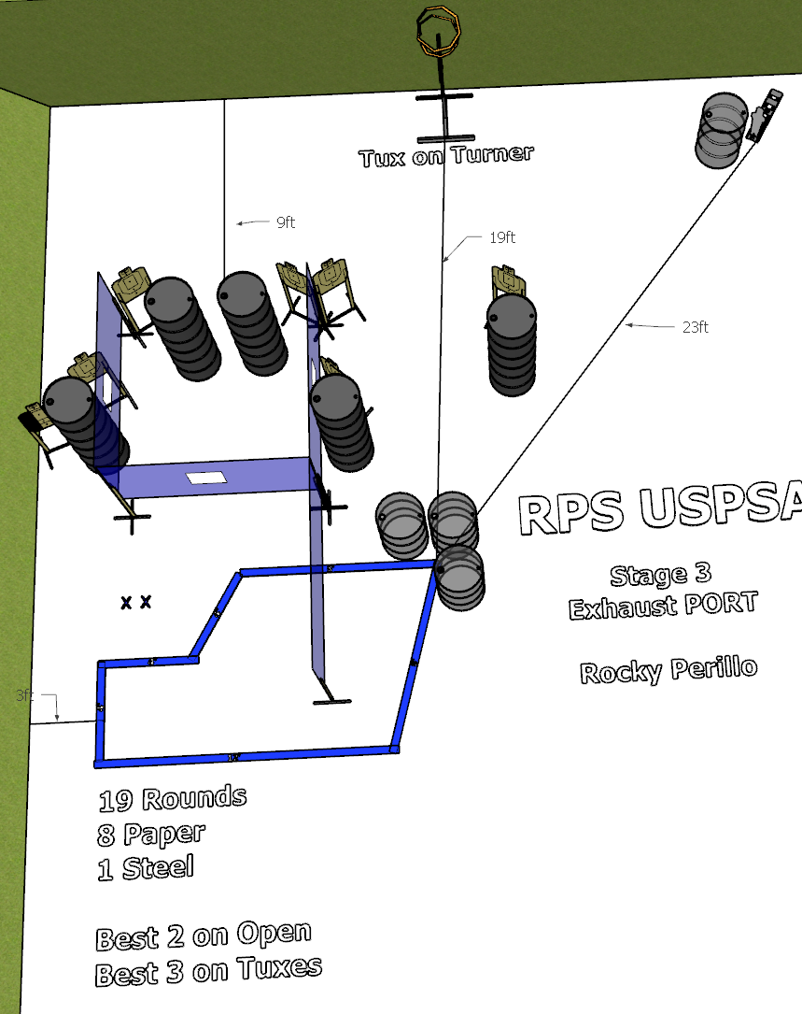

Written Stage Briefing:

Stage 3 – Exhaust Port - is a 19 round, 95 point, Comstock Course. There are 8 cardboard targets and 1 steel target.

The best 2 hits on open paper will be scored. The best 3 hits on Tux paper will be scored.

Starting both feet on Shooting Sports Innovations Xs.
Handgun is loaded and holstered, wrists below belt.
PCC is loaded held in both hands, stock on belt.

On the audible start signal, engage targets from within the shooting area.

Popper 1 activates Drop Turn target which is NOT visible at rest.

USPSA / NROI Range Commands:
- Make Ready
- Are you ready?
- Standby
- If finished, unload and show clear
- If clear, hammer down and holster (Handgun)
If clear, hammer down and flag (PCC)
If clear, cylinder closed and holster (Revolver)
- Range is clear

Setup Notes:
3 Single Wall Stands
1 Double Wall Stands
1 Triple Wall Stand
1 Full Wall
3 Port Walls
7 Target stands / 14 target sticks
1 Drop Turner + cables
1 Activator Popper + cables
14+ barrels
1 Start Xs


